**Ethereum Platform  
&  
Decentralized Application development**

# **Ethereum:**

Ethereum is a decentralized platform that runs smart contracts: applications that run exactly as programmed without any possibility of downtime, censorship, fraud or third-party interference.

Initial idea of Ethereum was conceived as ‘World Computer’ that would decentralize the existing centralized client-server model. In the existing model, data sent across the network to the client is controlled by central server. Server is powerful and data can be controlled by the owner of the server. Other than the control issue, this model is expensive, and suffers downtime too.

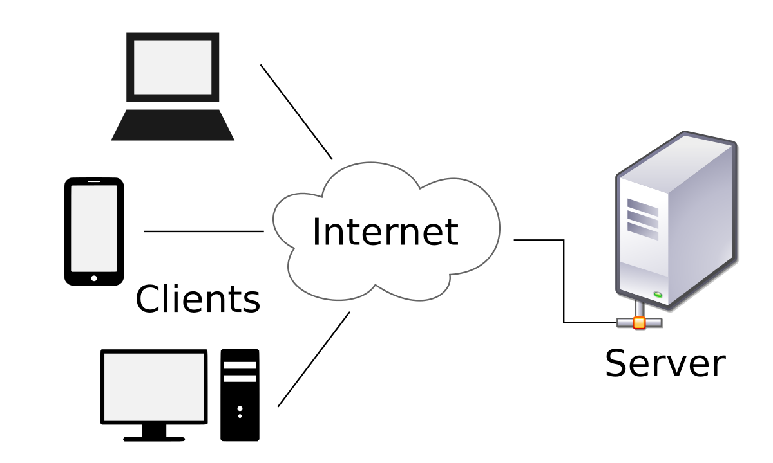

Blockchain technology, wipes out central server and make every client (called "nodes") across the globe as the server with each one having full control of data with consensus and hence is censorship proof (forming a ‘World Computer’).

Ethereum is an open source blockchain platform with built in programming language that allows developers to write, test and execute their decentralized application (contract). Data stored on Ethereum blockchain can be viewed by anyone but one having the private key can access it, and is the owner. Any transaction performed is anonymous, parties involved are always unknown. So, basically, Ethereum inherits all the blockchain characteristics and makes it easier for developers to deploy, run their applications and earn profits from it.

|  |  |
| --- | --- |
| Advantages | Disadvantages |
| * Anonymity. * Autonomous. * Zero possibility of downtime, censorship and fraud * It is easy for users to trust the application as it's not controlled by a single authority that could possibly cheat the users for profit. | * Applications are unable to update or remove after being released. * There is no central authority to verify the user identity, it becomes an issue for applications require verification of user identity * Size of network * Waste of resource |

# **Smart Contract:**

A contract is like a program, an application or just a class (OOP). A contract contains state variables, functions, function modifiers, events, structures, and enums. Contracts also support inheritance. Inheritance is implemented by copying code at the time of compiling. Smart contracts also support polymorphism. The smart contract will be deployed to the blockchain and be stored in a block so it’s immutable and transparent (such as blockchain characteristics). The most important thing of the smart contract is it automatically executes as it’s programmed, no need anyone or any-party control or run it. So we can trust the smart contract due to its immutable and automation.

Solidity is a language, which is OOP language base on JavaScript, use to write a smart contract. You can try it by follow this [link](https://remix.ethereum.org/).

# **DApp (Decentralized Application):**

A DApp is a kind of Internet application whose backend runs on a decentralized peer-to-peer network and its source code is open source. No single node in the network has complete control over the DApp. It is a combination of a frontend (you can choose any favorite framework such as Angular, Meteor, Vue.JS or React) and a smart contract (suggest to write in Solidity but you can use other languages such as Java, Python or Go) as a backend.

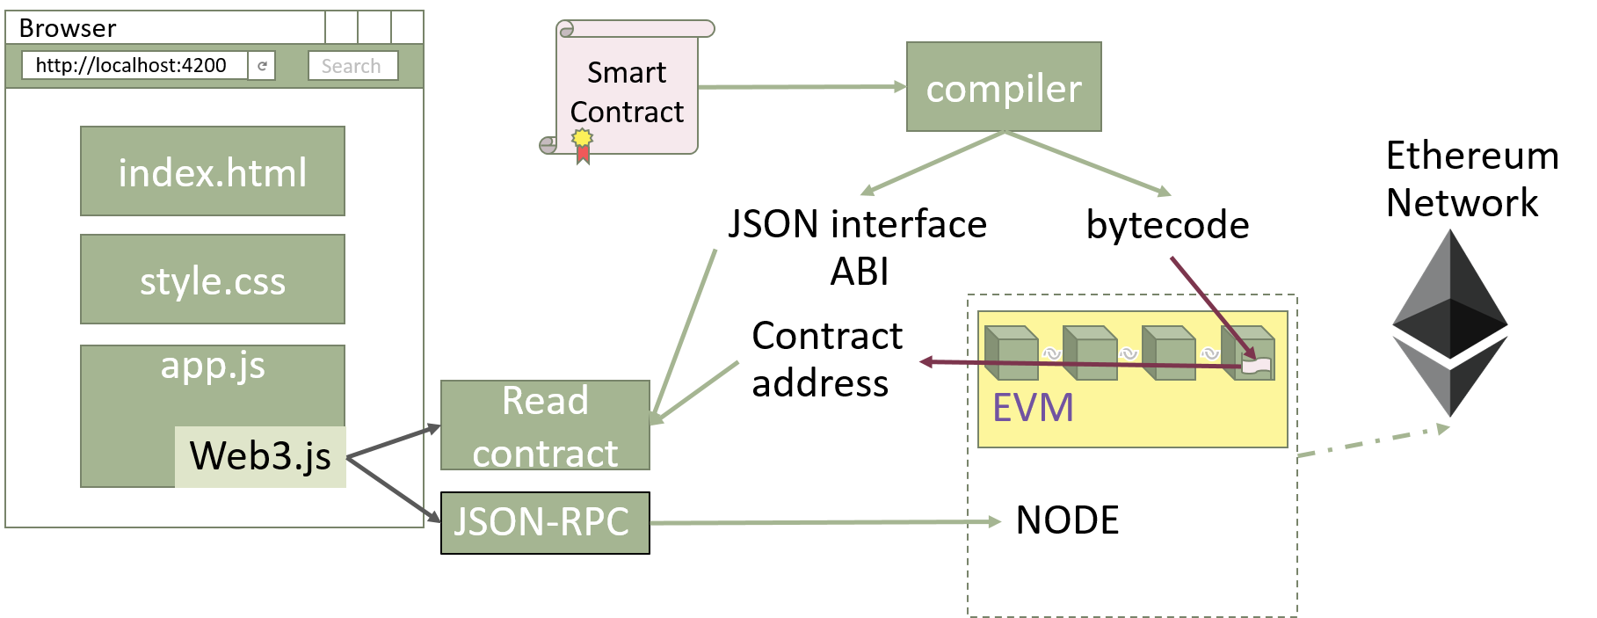

# **More information:**

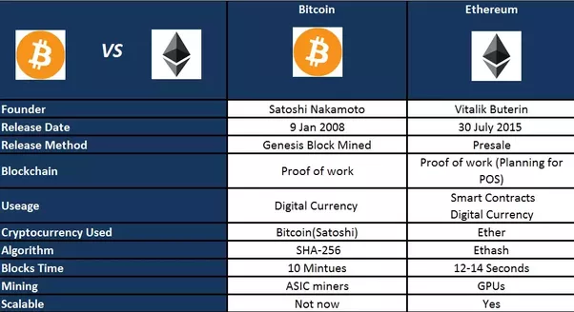

# **References:**

<https://www.ethereum.org/> <https://www.stateofthedapps.com/> <https://blockexplorer.com/>

<https://etherworld.co/2017/08/13/a-complete-guide-to-understand-ethereum-for-beginners/>

<https://steemit.com/blockchain/@alienhunt/pros-and-cons-to-building-on-ethereum>

<https://www.youtube.com/watch?v=ZE2HxTmxfrI>